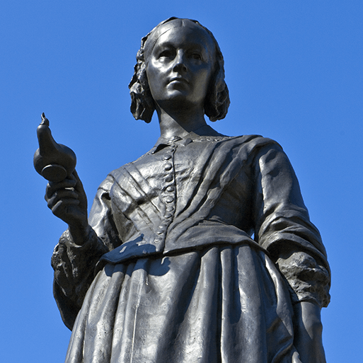

Movers and Shakers!
Year 2 Curriculum Map – Term 1
Experiences:
- Exploring habitats
- Food technology
This project teaches children about historically significant people who have had a major impact on the world.
Maths

This term we will be covering the following topics:
Place Value
- reading and writing numbers up to 100
- representing the value of digits in a 2 digit number
- ordering and comparing numbers
- counting in 10s, 2s, 5s and 3s
Addition and Subtraction
- consolidating number bonds to 10 and how they link to 20
- adding and subtracting 3 single digit numbers, a 2 digit number and ones, a 2 digit number and tens, and 2 2 digit number
- missing number problems
Shape
- naming 2D and 3D shapes and describing their properties
- sorting and comparing shapes
- pattern making and symmetry
English

This term we will be writing:
- A character description on Jack from the story Jack and the Beanstalk
- A biography of Malala Yousafzai
- Instructions on how to prepare to go into space.
- Poetry

Science
Children will be learning about the basic needs of humans for survival, including the importance of exercise, nutrition and good hygiene. They learn how human offspring grow and change over time into adulthood. They will also be learning about habitats and what a habitat needs to provide. They explore local habitats to identify and name living things and begin to understand how they depend on one another for food and shelter.
Geography
This essential skills and knowledge project teaches children about atlases, maps and cardinal compass points. They learn about the characteristics of the four countries of the United Kingdom and find out why there are hot, temperate and cold places around the world. They also compare England to Somalia. Children carry out fieldwork, collecting primary data in their locality to answer geographical questions.
History
Children will be learning about historically significant people who have had a major impact on the world. They will learn to use timelines, stories and historical sources to find out about the people featured and use historical models to explore their significance.
Design and Technology
This project teaches children about sources of food and tools used for food preparation. They also discover why some foods are cooked and learn to read a simple recipe. The children choose and make a new school meal that fulfils specific design criteria.
Art and Design
Children will be learning about basic colour theory by studying the colour wheel and colour mixing. It includes an exploration of primary and secondary colours and how artists use colour in their artwork. They will also be learning about the work of significant still life artists and still life techniques. They explore a wide variety of still lifes and learn about the use of colour and composition. They create still life arrangements and artwork.
Music
Children will be learning Hands, Feet, Heart which is a song written for children to celebrate and learn about South African Music. Children will also be learning the song Ho Ho Ho - a Christmas song. They will Listen & Appraise other styles of music and continue to embed the interrelated dimensions of music through games, singing and playing.
RE and Worldviews
Children will be learning about diversity within Islam, with a focus on ‘What do they believe and how may they live?’. Children will first learn about the 5 pillars of Islam. Then understand how Salat, Masjid, Aqiqah, and the Qur’an are celebrated/used to enable Muslims to follow the 5 pillars.
PSHE
Children will understand the difference between right/wrong and fair/unfair and that actions have consequences. They will understand the importance of love, listening and sharing in relationships. Also, they will know how to get help for bullying and about the impact of teasing. They will also understand how to respond to adults in a range of contexts, including online.

Computing
Children will develop their coding skills to define, create and debug simple programs and algorithms. They will know that, within the coding environment, different objects have different properties, there are different events, and the function of buttons. Using spreadsheet software, they will know how to copy, cut and paste, use totalling and perform calculations for purpose. They will also be able to create a manual block graph from data.

