EARL SPENCER PRIMARY SCHOOL



SEND Policy

Date reviewed: 8th January 2025
Approved by: Headteacher
Ratified by Governors:
Next review due by: January 2026

Contents
Contents  Introduction  Legislative Compliance  Definitions  Roles and responsibilities  Our approach to SEND support  Identification  Referral structure  Consulting with and involving parents  Graduated approach to SEND support  Assess, plan, do, review  Education, Health, Care Plans |  |  | 2
 |  |  | 3
 |  |  | 4
 |  |  | 4
 |  |  | 5
 |  |  | 7
 |  |  | 7
 |  |  | 9
 |  |  | 11
 |  |  | 11
 |  |  | 12
 |  |  | 13
Responding to behaviour of those with special educational needs |  |  | 14
Admissions  Supporting pupils at school with medical conditions  Safeguarding  Attendance |  |  | 14
 |  |  | 15
15
15
Effective transition  Complaints  Monitoring and evaluation arrangements  Links with other policies and documents |  |  | 16
 |  |  | 16
 |  |  | 16
 |  |  | 17

Introduction

Aims and objectives

Our special educational needs and disabilities policy aims to:
- Make sure our school fully implements national legislation and guidance regarding pupils with SEND
- Explain the roles and responsibilities of everyone involved in providing for pupils with SEND
- Explain how the school will communicate with pupils with SEND and their parents or carers and involve them in discussions and decisions about support and provisions for the pupil
- Ensure that all children requiring SEND provision are identified early, assessed and are provided with ongoing graduated provision.
- Ensure that all children can achieve their full academic and social potential.
- Ensure that good communication is maintained between school and parents and carers of children with SEND – enabling them to be fully informed of their child’s progress and be a part of the Assess, Plan, Do, Review cycle.
- Ensure that children with SEND are involved, where possible, in decisions impacting their provision.
- Ensure a high level of staff expertise to meet pupil need, through well targeted continuing professional development.
- Ensure the same high expectations for the good attendance of all pupils with SEND, alongside their peers.
- Explain how the school will help pupils fulfil their aspirations and achieve their best
- Explain how the school will help pupils with SEND become confident individuals living fulfilling lives

Vision and values

- At Earl Spencer Primary school, we believe that every child is an individual with unique needs and should have the same opportunities as their peers.
- We believe that every teacher is a teach of children with special educational needs and disabilities.
- We ensure all children are provided with a broad and balanced curriculum.
- We are committed to making sure all our pupils have the chance to thrive and support them to meet their full potential.
- We are focused on creating an inclusive environment, where provision is tailored to the needs and abilities of pupils, no matter how varied
- We encourage high aspirations and ambition for all members of our school community ensuring that all potential is fulfilled.
- We want children to have pride in themselves, their work, their achievements, their school and enjoy learning.

Legislative Compliance

- This policy complies with and takes its legal framework from the following statutory guidance:

- The SEND Code of Practice 2020
- The Equality Act 2010
- Keeping Children Safe in Education 2024
- SEND review: right support, right place, right time 2022
- Supporting pupils with medical conditions at school 2017
- Early Years Foundation Stage (EYFS) statutory framework 2024
- Working Together to Safeguard Children 2023
- Children and Families Act 2014
- Working together to improve school attendance 2024
- HM Government Special Educational Needs and Disabilities and Alternative Provision Improvement Plan 2023
- HM Government: The national strategy for autistic children, young people and adults 2021 – 2026.
- Behaviour in schools 2024.
- Mental health and behaviour in schools 2018

Definitions

- SEND: A child has special educational needs if they have a learning difficulties or disability that requires support that is, additional to or different from peers of their age.

- Disability: Pupils are considered to have a disability if they have a physical or mental impairment that has a substantial and long-term adverse effect on their ability to do normal daily activities

- The SEND Code of Practice 2020 identifies four broad areas of need:
- Communication and interaction: This includes children who have speech and language difficulties and also those identified as having an Autistic Spectrum Condition (ASC).
- Cognition and learning: This includes moderate and severe learning difficulties, when a child or young person learns at a slower pace that their peers in all areas of the curriculum. It also includes specific learning difficulties (SpLD) which may affect a more specific skill or area of the curriculum such as Dyslexia, Dyscalculia or Dyspraxia.
- Social, emotional and mental health difficulties: This can manifest themselves in many different ways, for example a child or young person may become withdrawn, or they may display very challenging and disruptive behaviour.
- Sensory and/or physical needs: This includes, among other things: Visual Impairment (VI); Hearing Impairment (HI) or a Multi-Sensory Impairment (MSI).

- Education and Health Care plan (EHCP) outlines any special education needs a pupil has, and the provision a local authority must put in place to help them. These were introduced in 2014 and gradually replaced Statements of SEN. Most children and young people should have transitioned from a statement to an EHCP.
- Reasonable adjustments: The duty to make reasonable adjustments for pupils with SEND is anticipatory. It requires thought in advance to what disabled children and young people might require and what adjustments might need to be made to prevent disadvantage and include the provision of auxiliary aids and services.
- The Local Offer: the directory published by the local authority which includes the education, health and social care services provided for children, young people and families who have SEN or disabilities accessible to pupils at the academy.

Roles and responsibilities
All staff in school have a responsibility for maximising achievement and opportunity for children with SEND. Staff are aware of their responsibilities towards all vulnerable learners and a positive and sensitive attitude is shown towards all pupils at all times.

Special Educational Needs Coordinator
The SENCO at our school is Emma Sturgess and she can be contacted by emailing esturgess@earlspencer.northants.sch.uk or by phoning the school office.
In line with the recommendations in the SEN Code of Practice 2014, the SENCO will oversee the day- to-day operation of this policy in the following ways:
- Work closely and liaise sensitively with parents and families of pupils on the SEND register, keeping them informed of progress and listening to their views of progress.
- Work with the headteacher and SEN governor to determine the strategic development of the SEND policy and provision in the school.
- Have day-to-day responsibility for the operation of this SEND policy and the co-ordination of specific provision made to support individual pupils with SEN, including those with EHC plans.
- Provide professional guidance to colleagues and liaise and work with staff, parents, and other agencies to make sure that pupils with SEN receive appropriate support and high-quality teaching.
- Advise on the graduated approach to providing SEN support and adaptive teaching strategies for individual pupils.
- Liaise with external agencies, including the local authority and its support services to ensure that appropriate provision is provided.
- Liaise with next providers of education to make sure that the pupil and their parents are informed about options and that a smooth transition is planned, ensuring that the relevant information about the pupils SEN provision are sent to them in a timely manner.
- Work with the headteacher and school governors to make sure the school meets its responsibilities under the Equality Act 2010 with regards to reasonable adjustments and access arrangements.
- Ensure that the school keeps its records of all pupils with SEND up to date and accurate.

- With the headteacher, monitor to identify any staff who have specific training needs regarding SEN and incorporate this into the school’s plan for continuous professional development.
- Regularly review and evaluate the breadth and impact of the SEND support the school offers or can access and cooperate with the local authority in reviewing the provision that is available within the local offer.
- Prepare and review information for inclusion in the school’s SEN information report and any updates to this policy.
- With the headteacher and teaching staff, identify any patterns in the school’s identification of SEN, both within the school and in comparison with national data and use these to reflect on and reinforce the quality of teaching.

The role of the governing body

The governing body is responsible for ensuring the following duties are carried out:
- Provision of a high standard is made for SEND students so that all children get the support they need.
- SEND pupils are fully involved in school activities alongside pupils who do not have SEND.
- Parents are informed when the school is making special educational provision for their child.
- School has arrangements in place to support any pupils with medical conditions.
- A broad and balanced curriculum is provided to all pupils.
- Have a clear approach to identifying and responding to SEND.
- Publish information on the school website about how the school is implementing its SEND policy, in a SEN information report.
- Ensure that there is a qualified teacher designated as SENCO for the school and that the key responsibilities of the role are set out.

The SEND link governor

The SEND link governor is Revd Sue Faulkner.
The SEND governor will:
- Help raise awareness of SEND issues at governing board meetings.
- Monitor the quality and effectiveness of SEND provision within the school and update the governing board on this.
- Work with the headteacher and SENCO to determine the strategic development of the SEND policy and provision in the school.

Headteacher

- Work with the SENCO and SEND link governor to determine the strategic development of the SEND policy and provision within the school.
- Work with the SENCo and school governors to make sure the school meets its responsibilities under the Equality Act 2010 with regard to reasonable adjustments and access arrangements.
- Have overall responsibility for and awareness of the provision for pupils with SEND.
- Ensure the SENCO has enough time to carry out their duties.
- Have an overview of the needs of the current cohort of pupils on the SEND register.
- With the SENCO, monitor to identify any staff who have specific training needs regarding SEN and incorporate this into the school’s plan for continuous professional development.
- With the SENCO, regularly review and evaluate the breadth and impact of the SEND support the school offers or can access.
- With the SENCO and teaching staff, identify any patterns in the school’s identification of SEN, both within the school and in comparison with national data and use these to reflect on and reinforce the quality of teaching.

Class teacher

Each class teacher is responsible for:
- Planning and providing high-quality teaching that is adapted to meet pupil needs through a graduated approach.
- The progress and development of every pupil in their class.
- Working closely with teaching assistants to assess and plan the impact of support and interventions and consider how they can be linked to classroom teaching.
- Working with the SENCO to review each pupil’s progress and development and decide on any changes to provision.
- Ensuring they follow this SEND policy and the information report.
- Identify children with possible SEND to refer to the SENCO, using knowledge from CPD and class assessment.
- Identify children that are underachieving and make classroom adaptions and monitor the progress.
- Ensuring that provisions outlined on Individual Education Plans and EHCPs are in place and are regularly reviewing, using school monitoring systems.
- Ensure that children working below their key stage are assessed using ‘Assessment for All’ framework.
- Ensuring there is adequate opportunity for pupils with SEND to work on agreed targets.
- Teachers that lead subjects will consider adaptions that need to be made for SEND learners to ensure that they can access the curriculum alongside their peers.

Our approach to SEND support

Identification of Need

- At Earl Spencer Primary School, we identify needs of pupils by considering the whole child and other factors that could impact on progress and attainment, such as: attendance and punctuality; physical and mental health and welfare; being a looked after child.
- We recognise that children need a range of teaching approaches and experiences dependent on their individual educational, physical and behavioural needs.

Early identification
Early Identification is a priority for us at Earl Spencer. In order to do this, the school will use a range of screens and assessment tools, alongside knowledge based CPD, to ascertain pupil progress. Class teachers will regularly assess the progress of all pupils and identify any whose progress:
- Is significantly slower than that of their peers starting from the same baseline.
- Fails to match or better their previous rate of progress.
- Fails to close the attainment gap between them and their peers.
- Widens the attainment gap between them and their peers.

When teachers identify an area where a pupil is making slower than expected progress, they will target the pupil’s area of weakness with differentiated, high quality teaching using strategies outlined in Wave 1 of our provision map. If progress does not improve, the teacher will submit a referral form to the SENCO and initial discussions will be held about whether this lack of progress is due to a special educational need. Slow progress does not automatically mean a pupil will be recorded as having SEN and potential short-term causes, and external factors will first be considered.

The school will also identify potential SEN by:
- Monitoring conducted through termly pupil progress meetings
- Referrals to the SENCO may result in screening and diagnostic tests
- Working closely with parents so they are able to discuss their concerns
- Acquiring handover from previous schools and nurseries
- Conducting home and nursery visits to observe the child before they begin in EYFS

Referral structure

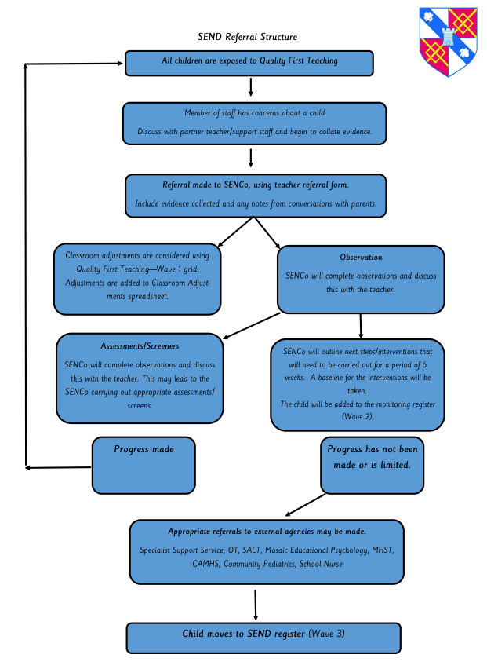

Our referral structure for children in EYFS

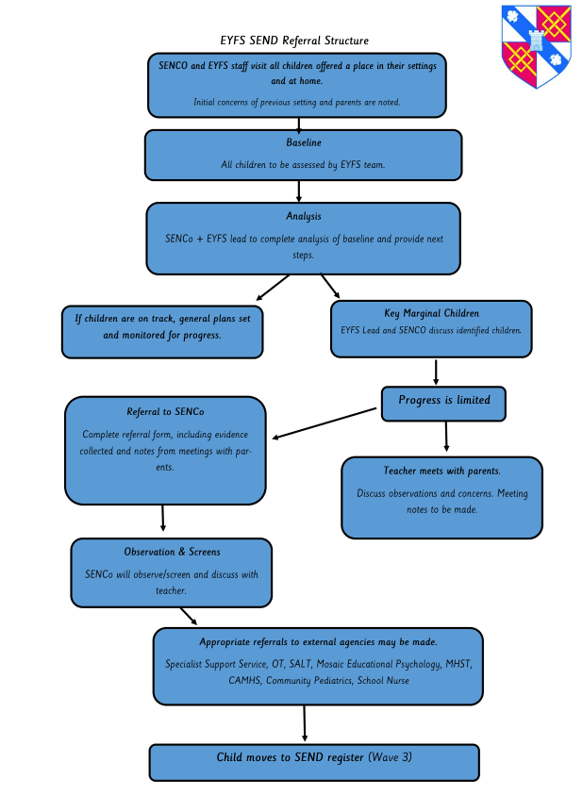

Consulting with and involving parents and pupils

The school will put the pupil and their parents at the heart of all decisions made about special educational provision.

When we are aiming to identify whether a pupil has a special educational need, we will have an early discussion with the pupil and their parents. These conversations will ensure:
- Everyone develops a good understanding of the pupil’s areas of strength and difficulties.
- Allow the parents discuss any concerns that they have
- Allow everyone to understand the agreed outcomes and next steps for the child
- Pupil voice will enable school to view the pupil as the ‘whole child’ before planning their next steps

Graduated Approach to SEND Support

At our school, we use a ‘wave’ system to determine the type of support best suited to each child.

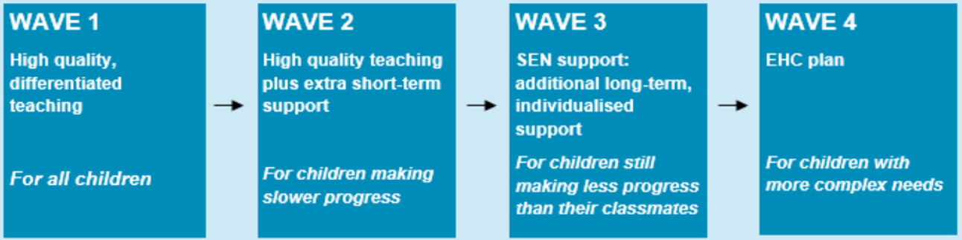

When teachers identify that a pupil is making slower than expected progress and adaptive teaching strategies outlined in Wave 1 of our provision map has not demonstrated expected progress, the teacher will work alongside the SENCO to plan interventions as outlined in Wave 2 of our provision map. These interventions will target the pupil’s area of weakness and will be monitored over a 6 week period.

If after 6 weeks no progress or little progress has been made, the SENCO will complete observations and necessary assessments to identify a possible special educational need, whilst working closely with parents to gain their perspective. If it is determined that a child may have a special educational need and they require ‘additional to or different from’, they will move to wave 3 of our graduated approach. This will involve the child being placed on our SEN register and an Individual Education Plan being created in conjunction with the SENCo, Class Teacher and parents.

Assess, Plan, Do, Review

Once a pupil has been identify as having SEN, we will take action to remove barriers to learning and put effective special educational provision in place. This support will be delivered through successive rounds of a 4-part cycle.

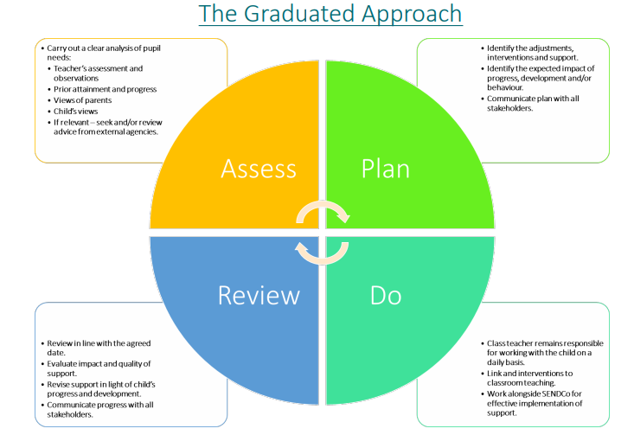

Assess

The pupil’s class teacher and the SENCO will carry out a clear analysis of the pupil’s needs.. Where appropriate, the SENCO may run diagnostic screens and gather information from parents and carers.

Target areas will be selected and baselines will be created, which will enable staff to monitor the progress throughout the cycle.

Plan

In consultation with the parents and the pupil, the teacher and the SENCo will decide which adjustments, interventions and support will be put into place, the expected outcomes and a clear date for review.

All staff who work with the pupil will be made aware of the pupil’s needs, the outcomes sought, the support provided and any teaching strategies or approaches that are needed. This information will be recorded on a learning plan and will be accessible to staff.

Parent will be invited to a meeting to discuss this and will be provided with a copy of the learning plan. They may also be asked to reinforce or contribute to progress at home.

Do

The pupil’s class teacher retains overall responsibility for their progress. They will ensure that the curriculum is properly sequenced, reducing barriers experienced by pupils with SEND.

Where the plan involves group or 1:1 teaching away from the main class teacher, they still retain responsibility for the pupil. They will work closely with any teaching assistants involved to plan and assess the impact of the support and interventions and how they can be linked to classroom teaching.

The SENCO will support the teacher in further assessing the pupil’s particular strengths and weaknesses and advising on how to implement support effectively.

Review

The effectiveness of the support and the interventions and their impact on the pupil’s progress will be reviewed in line with the agreed date. The school agrees to meet with parents at least three times each year.

We will evaluate the impact and quality of the support and interventions. This evaluation will be based on:
- The views of the parents and pupils
- The level of progress the pupil has made from their baseline towards their outcomes
- The views of teaching staff who work with the pupil

The teacher and the SENCO will revise the outcomes and support in light of the pupil’s progress and development, alongside the views of the pupil and their parents.

Where a pupil continues to not make adequate progress, despite additional provision at SEND support, the school may seek advice and involvement from external support services.

Involvement of pupils within our assess, plan, do, review cycle

We recognise that all pupils have the right to be involved in making decisions and exercising choice. We endeavour to fully involve all pupils by encouraging them to:
- State their views about their education and learning
- Identify their own needs and learn about learning
- Share in individual target setting across the curriculum so that they know what their targets are and why they have them,
- Self-review their progress and identify their strengths and challenges over the past term
- For some pupils with special educational needs, monitor their success at achieving the targets on their Individual Education Plan.

Education, Health, Care Plans

If deemed appropriate, after relevant evidence has been collected, the school and/or parents may decide to request that the local authority undertakes a statutory assessment. This may lead to a pupil being provided with an EHCP.

The SENCO is responsible for providing support, monitoring and ensuring that pupils with EHCPs received the specified support. The SENCO will take a lead on strategic decisions regarding target setting, monitoring and reviewing outcomes for all pupils, in conjunction with class teachers and members of the senior leadership team.

The progress of children with EHCPs will be monitored weekly through a target monitoring system. This will be carried out by class teachers, in conjunction with the teaching assistant working with the pupil. If it is deemed that a child is not making expected progress towards their targets, class teachers will discuss this with the SENCO so that the strategies and provisions in place can be reviewed before the agreed date to ensure that the child makes consistent progress.

Internal Alternative Provision

We believe that every pupil in our school has the opportunity to thrive. Some pupils, including those with SEND, may require a bespoke learning and/or therapeutic learning environment to enable them to access their curriculum. A clear rational for this internal alternative provision is developed for internal alternative provision, which will focus on one or two key areas of need as opposed to all needs in one setting.

Responding to behaviour of those with special educational needs

- We have high expectations for all pupils and provide additional support where needed to ensure pupils can achieve and learn as well as possible. All staff will seek to understand the underlying causes of behaviour and to determine where additional support is needed. Where a child has special educational needs, the graduated approach will be used to assess, plan, deliver and then review the impact of this support. Staff will also identify and anticipate likely triggers for detrimental behaviours and put support in place to prevent these and these will be logged on an individual behaviour plan.
- We will consider whether a pupil’s SEND has contributed to their detrimental behaviour and if so, whether it is appropriate and lawful to sanction the pupil. In considering this, schools will refer to the Equality Act 2010.
- Where we have concerns about the behaviour, or risk of suspension and permanent exclusion, of a pupil with SEND or an EHC plan, we will work in partnership with the local authority to consider what additional support may be required.

Admissions

The admissions criteria should not discriminate against pupils with SEND. The admission of pupils with an EHCP will fall outside of the usual admissions process.

In line with the Children and Families Act 2014, our school will:
- Not refuse to admit a child with SEND but does not have an EHCP because it does not feel able to cater for those needs
- Consider applications from parents of children who have SEND but do not have an EHCP as part of the normal admission procedure
- Will not refuse to admit a child on the grounds that they do not have an EHCP

Supporting pupils at school with medical conditions

- Some pupils with medical conditions may be considered to be disabled under the definition set out in the Equality Act 2010. In this case, we will comply with the duties under that Act.
- Where a pupil with a medical condition has SEND but does not have an EHCP, their special educational needs will be included in a individual healthcare plan.
- Where a pupil with a medical condition has an EHCP, their special educational needs will be linked with their healthcare section within their EHCP.
- We will recognise that pupils with medical conditions need to be properly supported so they have access to education, including school trips and physical education.
- Reasonable adjustments will be made for the pupil to ensure that they receive a suitable education that meets their needs.
- Where a pupil has a medical condition, individual healthcare plans will be updated yearly and review meetings will be held where necessary.

Safeguarding

We recognise that pupils with special educational needs (SEN) and disabilities can face additional safeguarding challenges. Additional barriers can exist when recognising abuse, neglect and exploitation in this group, including:
- assumptions that indicators of possible abuse such as behaviour, mood and injury relate to the child’s disability without further exploration;
- pupils being more prone to peer group isolation than other pupils;
- the potential for pupils with SEN and disabilities being disproportionally impacted by behaviours such as bullying, without outwardly showing any signs; and/or
- communication barriers and difficulties in overcoming these barriers;
- recognising the additional risks that children with SEND face online, such as, online bullying, grooming and radicalisation and are confident they have the capability to support children with SEND to stay safe online.

The senior leadership team will ensure that children are taught about safeguarding, including online safety and recognise that some pupils with SEND may need a more personalised or contextualised approach. We also offer extra pastoral support for pupils with SEN and disabilities. This may include support from wellbeing mentor, counselling etc.

Attendance

We have high expectations for good attendance, including for those with SEND but understand that some of these pupils face greater barriers to attendance than their peers. We will put additional support in place where necessary to help these pupils in order for them to access full time education. This will include:
- Removing in-school barriers these pupils face. This may include considering reasonable adjustments in regards to uniform, routines, access to support in school and lunchtime arrangements.
- Working with the local authority or health services to access wider support
- Working with parents to support routine and signposting to relevant support groups where appropriate.
- Alternative provision may need to be sought from the local authority if a child has a long-term illness or other health needs
- Liaising closely with parents of pupils with low attendance to understand the barriers and challenges to their child’s attendance.

Effective Transition

- We will ensure early and timely planning for transfer to a pupil’s next phase of education and, in the year before the year in which they leave, will offer transition meetings to all pupils who have Individual Education Plans. Pupils with Education Health and Care Plans will have transition arrangements discussed at plan review meetings.
- A transition timeline will be produced, with specific responsibilities identified.
- For some children, a transition programme will take place from the spring term.
- Support for the pupil in coming to terms with moving on will be carefully planned and will include familiarisation visits and counselling. Pupils will be included in all “class transition days” to the next phase but may also be offered additional transition visits if necessary.
- Pupils and parents will be encouraged to consider all options for the next phase of education and the school will involve outside agencies, as appropriate, to ensure information is comprehensive but easily accessible and understandable. Accompanied visits to other providers may be arranged as appropriate.

Complaints

Where parents have concerns about our school’s SEND provision, they should first raise their concerns informally with the SENCO. We will try to resolve the complaint informally in the first instance. If this does not resolve their concerns, parents are welcome to submit their complaint formally.

More information regarding our school’s complaints policy can be found on our school website.

Monitoring and evaluation arrangements

We are constantly looking for ways to improve our SEND policy. We will do this by evaluating whether or not we are meeting our objectives set out in the aims and objective of this policy and by reviewing the effectiveness of our SEND action plan.

We will evaluate how effective our SEND provision is with regards to:
- Staff’s awareness of pupils with SEND at the start of the autumn term
- How early pupils are identified as having SEND
- Pupil’s progress and attainment once they have been identified as having SEND
- Whether pupils with SEND feel safe, valued and included in the school community
- Comments and feedback from pupils and their parents

This policy will be reviewed by the SENCo every year. It will also be updated when any new legislation, requirements or changes in procedure occur during the year.

Links with other policies and documents
This policy links to the following documents:
- SEN information report
- The local offer
- Accessibility plan
- Behaviour policy
- Attendance policy
- Safeguarding policy
- Complaints policy
- NCC admissions policy

