

Sow, Grow and Farm
Year 5 Curriculum Map – Term 2
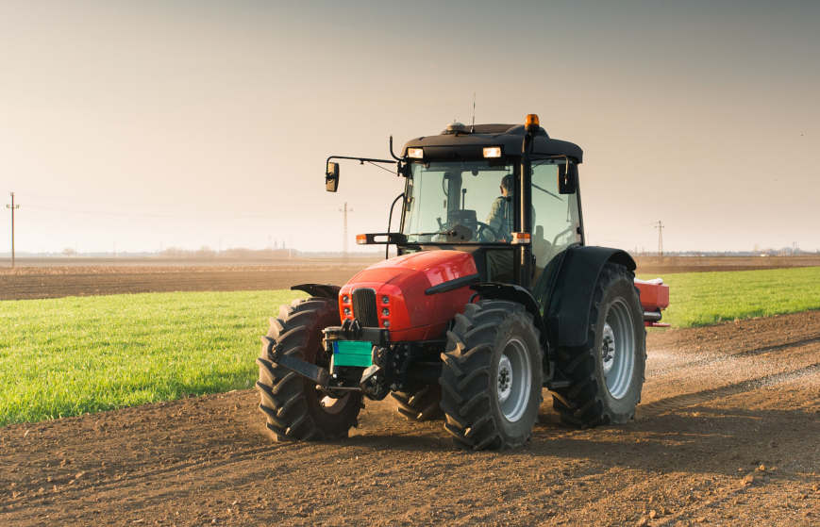
Experiences:
- Trip to a farm
- Plan and make a seasonal meal.
- Church visit
This project teaches children about the features and characteristics of land use in agricultural regions across the world, including a detailed exploration of significant environmental areas.
English

This term we will be writing a range of genres, Setting description, non-chronological report, balanced arguments, leaflets, and a persuasive poster.

For each of these genres, the children will learn about the genre specific textual and grammatical features. The textual features will include aspects such as bullet points, subheadings, pictures, and captions. The grammatical features will be the use of formal and informal language, generalisations, technical vocabulary, and figurative language such as rhetorical questioning.

Grammar
In our grammar work the children will explore the use all forms of parenthesis, expanded noun phrases and using the correct tense within their writing.

Handwriting
In handwriting the children will focus on ensuring that they form their letters correctly and will there fore be able to join their letter correctly. They will also develop their understanding of the appropriate size and spacing for their handwriting.

Whole Class reading
In whole class reading, we will study the book Charlotte’s Web by E.B. White. They will be developing their reading skills of prediction inferring and retrieval of information from a text and summarising the text.

Spelling
In spelling the children will continue to use Spelling Shed to help them to continue to develop their understanding of etymology and how to use suffixes and prefixes effectively.

Maths
This term we will be covering the following topics:

Multiplication and division
Multiply and divide numbers mentally drawing upon known facts. Multiply and divide numbers up to 4 digits by a one- or two-digit number using a formal written methods.

Fractions
Multiply a fraction / non-unit fraction by an integer. Multiply a mixed number by an integer. Calculate a fraction of a quantity or amount.
Recognise missing fraction to find the whole.

Decimals and percentages
Read, write, order and compare numbers with up to three decimal places. Recognise and use thousandths and relate them to tenths, hundredths and decimal equivalents. Round decimals with two decimal places to the nearest whole number and to one decimal place.

Perimeter and area
Measure and calculate the perimeter of composite rectilinear shapes in centimetres and metres. Calculate and compare the area of rectangles (including squares), and including using standard units, square centimetres (cm2) and square metres (m2) and estimate the area of irregular shapes.
Statistics
Solve comparison, sum and difference problems using information presented in a line graph. Complete, read and interpret information in tables, including timetables.

Geography

Sow, Grow and Farm

This project teaches children about the features and characteristics of land use in agricultural regions across the world, including a detailed exploration of significant environmental areas.
PSHE

Children should understand the importance of respectful behaviour in online relationships/activity. They should also understand when information should be kept confidential. Children should know how to seek help with unsafe/unhappy family relationships. As well as this, they should understand appropriate and inappropriate physical contact. They should also have further developed their listening, speaking and cooperation skills.

Art

Line, light and shadows
This project teaches children about the visual qualities of line, light and shadow. They explore the work of Pablo Picasso and Rembrandt and are introduced to a range of shading techniques. They take black and white photographs and use pencil, pen and ink wash to reimagine their photographs in a shaded drawing.

Natures Art
This project teaches children about the genre of land art. They work outdoors to sketch natural forms and explore the sculptural potential of natural materials before working collaboratively to create land art installations.

Science

Human Reproduction and Ageing

This project teaches children about animal life cycles, including the human life cycle. They explore human growth and development to old age.
RE

Are Sikh stories important today?
The children will understand that the Guru Granth Sahib is treated as a living Guru. They will be able to explain how the Guru Granth Sahib is treated with respect. They will also be able to explain why the texts are important to Sikhs

How significant is it for Christians to believe God intended Jesus to die?
The children will understand the events of the holy week, Maundy Thursday, Good Friday, Holy Saturday and Easter Sunday. They will understand that for the Christian understanding of Salvation Jesus had to die so he could be resurrected and restore humanity’s relationship with God.

Computing

Spreadsheets
Using spreadsheets, children will be able to use more advanced formulae effectively, including for conversions and with text variables. They will also know how to use tools within a spreadsheet to answer hypotheses.

3D Modelling
Children will understand the purpose, skills and function of modelling software and computer aided design. They will know the effects of moving points when designing. They will also know how to design to fit criteria and refine and print their models.

Design and Technology

Eat the Seasons
This project teaches children about the meaning and benefits of seasonal eating, including food preparation and cooking techniques.

French
The French Speaking World

Discovering the many French-speaking countries, giving and following directions in French and discussing climate using comparative language.

Verbs in French
Pupils identify the infinitive form of verbs, and subject pronouns, then group French verbs into -er, -ir and -re categories before learning the -er regular verb endings, practising with a set of regular action verbs; they discover that not all verbs are regular and learn the foundation verbs ‘avoir’ and ‘être’, and finally produce a short piece of creative writing to demonstrate their learning.

Music

Blown away
The children will learn how to play the following notes on a recorder B,A,G,D ,F , C and high D and then apply their knowledge to a number of different pieces.

Make You Feel My Love
In this unit of work, all the learning is focused around one song: Make You Feel My Love. The material presents an integrated approach to music where games, elements of music (pulse, rhythm, pitch etc), singing and playing instruments are all linked. As well as learning to sing, play, improvise and compose with this song, children will listen and appraise other Pop Ballads.

