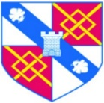
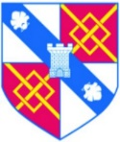
Dynamic Dynasty
Year 5 Curriculum Map – Term 1
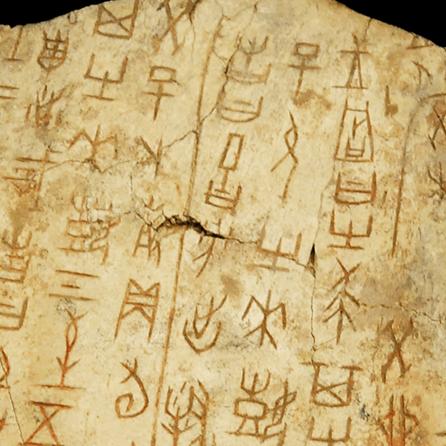
Experiences:
- Visit From Rev Sue
- Field work for geography.
This project teaches children about the history of ancient China, focusing primarily on the Shang Dynasty, and explores the lasting legacy of the first five Chinese dynasties, some of which can still be seen in the world today.
English

This term we will be writing:
- Non chronological reports
- Narratives based on stories from other cultures.
- Narrative poems
- Biographies
- Newspaper reports
Maths
This term we will be covering the following topics:
Place value
- Place value up to 1,000,000
- Roma numerals
- Powers of 10
- Number lines
- Comparing and ordering numbers to 1, 000, 000
- Rounding to 1,000,000
Addition and subtraction
- Mental strategies
- Adding and subtracting
- Rounding
- Inverse and multi-step problems
- Finding missing numbers
Multiplication and division
- Multiplies
- Common multiplies.
- Factors
- Prime numbers, square numbers
- Cube numbers
- Dividing and multiply 10,100,1000
Fractions
- Equivalent fractions to a unit fraction
- Recognise equivalent fractions.
- Convert improper fractions to mixed numbers.
- Compare fractions less than 1 Order fraction less than 1
- Add fractions within 1
- Subtract fractions.

Design and Technology
This project teaches children about pneumatic systems. They experiment with pneumatics before designing, making and evaluating a pneumatic machine that performs a useful function.
Reading
This term we will be exploring a range of genres including poetry, non-chronological reports, stories from other cultures, picture stories, stories based on dilemmas, classical texts, and web pages.
We will be practising our retrieval, inference, vocabulary, and prediction skills.
History
In Dynamic Dynasties, your child will learn about periods of ancient Chinese history. They will explore a timeline of the first five Chinese dynasties and learn about the legends surrounding the beginning of Chinese civilisation. They will study oracle bones, learn about religious beliefs and explore bronze artefacts that set the Shang Dynasty apart from other civilisations. They will also study the hierarchy of the Shang Dynasty and discover who was powerful and who was powerless. They will look at warfare and find out how bronze technology gave the Shang Dynasty an advantage over their enemies. They will learn about the life of the great military leader, Fu Hao.
Geography
During the Investigating Our World project, your child will study Ordnance Survey maps to write a description of the local area. They will learn about contour lines and revise six-figure grid references to locate features on maps. Your child will learn about the Prime, or Greenwich, Meridian and find out that Greenwich Mean Time, or GMT, is taken from the Prime Meridian. They will know that the Earth is split into 24 time zones and calculate the time in places worldwide. Your child will learn about climate zones, vegetation belts and biomes. They will find out that the climate and vegetation in an area determine the animals that live there. Your child will learn about the human geography of the continents and locate capital cities around the world. They will identify relative locations and use the scale bars on maps to find the distance between places. They will study the motorway network across the United Kingdom, learning how they connect towns, cities and transport links across the country. Your child will explore a settlement hierarchy diagram and learn about the relative size, significance and populations of settlements. At the end of the project, they will carry out a fieldwork enquiry to discover which settlement types are in their local area.
Science
Forces and Mechanisms
In the Forces and Mechanisms project, your child will revisit prior learning about forces, identifying what a force is and discussing the two types, including contact and non-contact forces.. They will learn the meanings of the terms 'mass' and 'weight' and their units of measurement, following instructions to record the mass and weight of various everyday objects using a piece of equipment called a force meter. They will learn about the frictional forces called air and water resistance in detail and conduct investigations to observe these frictional forces in action. They will learn about mechanisms, including gears, pulleys and levers and follow instructions to investigate how these simple machines use forces to make tasks easier.
Earth and space
In the Earth and Space project, your child will learn the names of the planets in the Solar System. They will learn how scientists throughout history used different methods to study the Solar System and came to understand how the planets orbited the Sun. They will identify the spherical shape of the Sun, Earth and Moon. They will know that the Earth's rotation creates a range of phenomena, including day and night and the appearance of the Sun rising above the horizon in the east at sunrise, moving across the sky and then setting below the horizon in the west at sunset.
Art and Design
Landscapes in colour
This project teaches children about colour theory by studying tints, shades and tones. They learn about the features of landscapes before using this knowledge to create landscape paintings.
Taotie
This project teaches children about the significance and art of the taotie motif, including ancient and contemporary casting methods.
French
French Monster
The ‘French Monster’ unit will review noun gender, article-noun agreement and adjective placement while exploring monster and body part vocabulary writing and presenting paragraphs about a ‘Fantastic French beast’ creation.
Shopping in France
Pupils learn to construct high numbers in French, develop food-related vocabulary through games, stories and role-play and build on their understanding of sentence structures, questions and phrases, equipping themselves with language they could use when shopping in France.
PSHE
Children should know the harmful effects of drugs, alcohol, substance abuse and smoking. They should be able to use strategies for managing strong emotions surrounding loss and grief and understand the cycle of life and death. As well as this, they should understand the physical and emotional changes during puberty. They should know the mental and physical benefits of being healthy and how to maintain physical and mental health, and emotional wellbeing. They should also know the concepts of basic first aid.
Music
Livin’ On a Prayer
This is a six-week Unit of Work. All the learning is focused around one song: Livin' On A Prayer. The material presents an integrated approach to music where games, the dimensions of music (pulse, rhythm, pitch etc), singing and playing instruments are all linked.
Classroom Jazz 1
This Unit of Work focuses on improvising. Using two great pieces, Three Note Bossa and Five Note Swing, the pupils will learn to play the pieces and then explore improvising with the repertoire.

Computing
Children will begin to know how to simplify code for efficiency. They will be able to understand and use decomposition and abstraction to remove superfluous details and make a plan. They will also understand and use a function for efficiency. They will also know different types of variables and set and change these, including text variables. They will also know the functions of and use strings and concatenation. Using databases, they will be able to: search for information in different ways, including how to phrase questions; add information to a shared database; create a database; create records; use fields and add information.
RE
Sikhism: How far would a Sikh go for his/her religion?
At the end of the unit, the children can identify the meaning of the 5 K’s, and the approach to marriage and explore the Golden Temple. They will be able to explain why these are important to Sikhs.
Christianity : Is the Christmas Story true?
The children will understand that while the Birth stories of Jesus have different emphases they do not disagree with each other and agree on all main points.

